Learning to Count by Coloring Food Items

Numbers 1 to 5

Circle the correct number of pumpkins.
1 2 3 4 5
Color the pumpkin with an orange crayon.

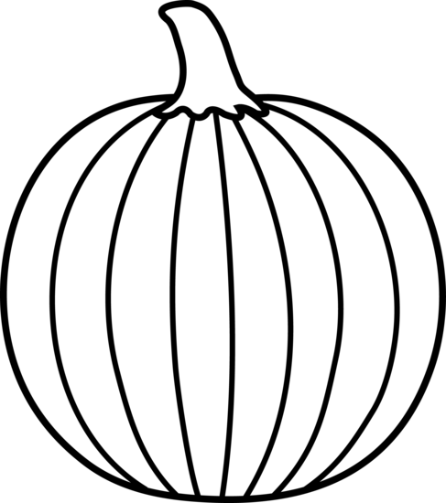

Circle the correct number of acorns. 1 2 3 4 5
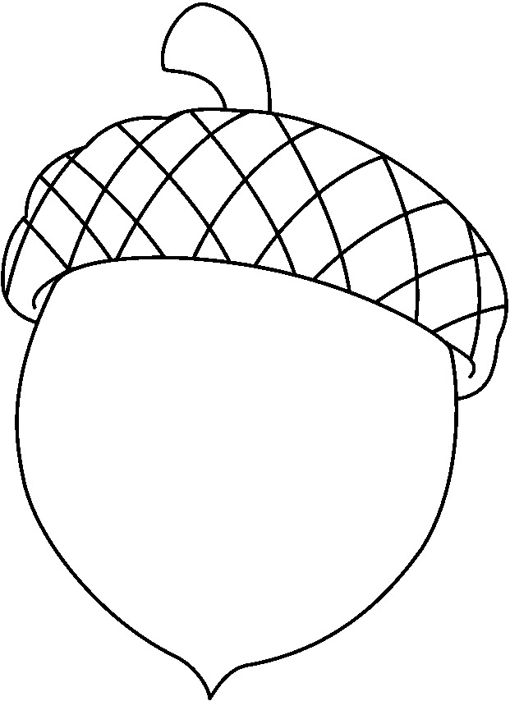
Color each acorn with a brown crayon.

Circle the correct number of pears. 1 2 3 4 5
Color each pear with a green crayon.
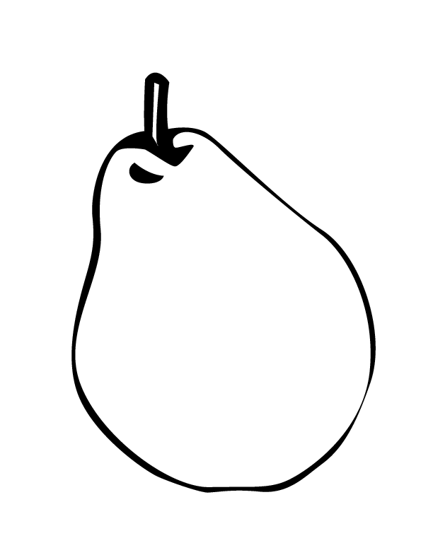

Circle the correct number of apples. 1 2 3 4 5
Color each apple with a red crayon.

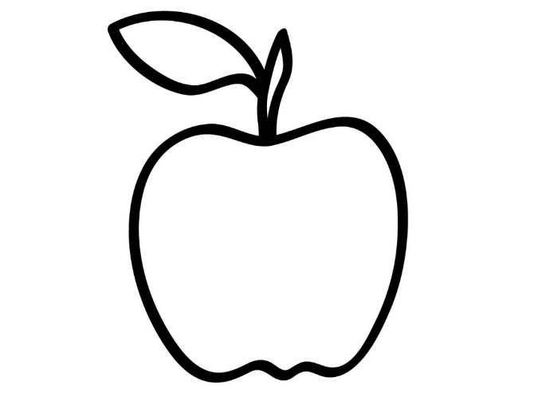

Circle the correct number of peaches. 1 2 3 4 5
Color each peach with a yellow crayon.
